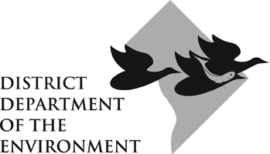
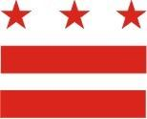

DDOE Watershed Protection Division
Work Plan Template

Appendix 4

Chart out your “Activities” in a Work Plan table similar to the one designed below. (Note: You may modify this chart’s format if necessary.) A Work Plan takes the ideas presented in a grant application and turns those ideas into a series of actionable steps that move a project from a concept toward an outcome. The Work Plan should break the long term goal (or outcome) into activities that create a series of discreet short term steps. Those activities can then be turned into quantifiable results (or outputs).

The following should be included or referenced in a Work Plan: an up-to-date budget (see Appendix 3, the budget format); phasing; a timeline; a list of private and public partners; and a breakdown of outcomes, outputs and activities with associated timelines and responsible parties.

Service #:

Activity | Task(s) | Output | Outcome | Person(s)  Responsible | Completion Date
The Work Plan is a document that will not only help the Grantee to strategize implementation, but will also facilitate communication between the Grantee and the DDOE. The Work Plan should lay out important milestones like the dates Progress Reports and Final Reports are due and the dates for the completion of activities specified in the grant agreement. The Work Plan is not meant to be a rigid document, but rather a framework that provides organization. The Work Plan is based on the grant’s approved scope of activities. But the Grantee should communicate with their DDOE grant manager frequently, especially if the Work Plan schedule needs to be adjusted. Please contact the Grant Administrator to see examples of work plans, should you need them.

