DDOE Grant’s
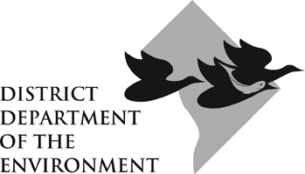
Final Reporting Template

Length of Report:

Please make the length commensurate with requirements in the Notice of Grant Award and the size of the grant.

List your:
- Project Title, and DDOE RFA and Project Number
- Entire Award Period, and any previously unreported Progress Report period
- Organization’s name
- Organization’s primary contact person(s) -- telephone, fax, and email

Has your project been completed? If not, briefly summarize the completion status and barriers your project has faced.

For this final report, list your entire project’s:

- Specific activities conducted
Activities are undertaken to achieve the outputs and outcomes. For example, materials developed and distributed, events hosted, etc.
- Outputs achieved
Outputs are short-term results achieved such as the number of rain gardens installed and pounds of nitrogen/phosphorous/sediment removed. Outputs must be quantified.
- Outcomes achieved (if applicable)
A project outcome is a medium- to long-term result that occurs. For example, an outcome could be increased public awareness of the effects of stormwater run-off.

Note: You may include the Activities/Outputs/Outcomes detailed in previous Progress Reports and/or Work Plan.

Include in this final report copies of any materials produced as part of this project (marketing pieces, curriculum, interpretive signage, etc.).

Note: If you have submitted these materials with previous Progress Reports, you do not need to resubmit.

Detail your budget’s status. If your expenditures are off-track, please explain why. If on-track, you may submit an invoice for the remaining amount with this Final Report.

[Filename: 0 App 7 Report - Final Template.docx]

