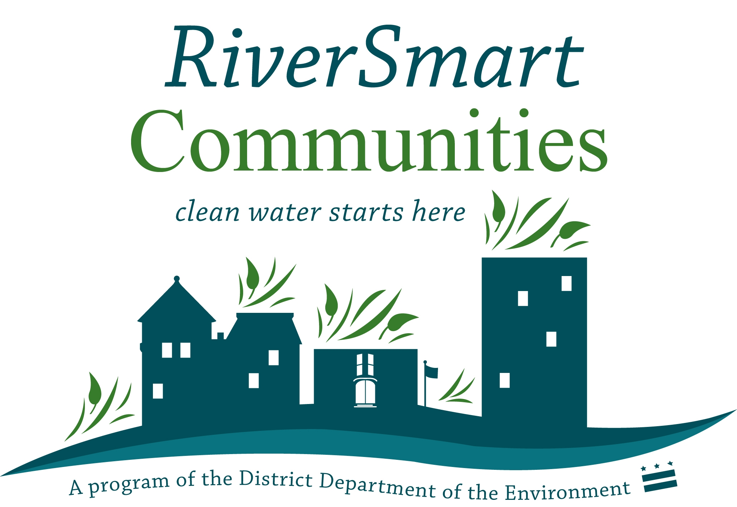
Rebate Application

The RiverSmart Communities program offers rebates for up to 60% of the project cost of Low Impact Development practices such as rain gardens, cisterns, and permeable pavement on multifamily residential properties, houses of worship and small, locally owned businesses. To apply, submit the following application and supporting documents electronically to Mary Abe at mabe@anacostiaws.org.

The RiverSmart Communities program is administered by the Anacostia Watershed Society (AWS). Applications will be reviewed on the last Thursday of each month. Awards will be granted based on environmental benefit, cost-effectiveness, and feasibility. Applicants will be notified on the status of your grant within one week of review. The review committee will either grant funding, suggest changes in project to make it fit DDOE requirement or declined. If changed are suggested, you may resubmit the application for the next month’s application review meeting.

I. Building Information
Name of Building: __________________________________
Address: __________________________________________
Type of Building:
House of worship Apartment Complex Condominium
Cooperative Business Other __________

Search address on http://dcatlas.dcgis.dc.gov/ddoe/ to find the following information:
Latitude/Longitude: _________________________________
Watershed (circle one): Anacostia Rock Creek Potomac
Sewer system (circle one): CSS or MS4

II. Implementation Team - Teams must include at least three individuals which may include members of the homeowner, condominium, or apartment board, maintenance/grounds representative, resident, building owner, and/or other building users as appropriate. Please indicate a project leader/head contact with an asterisk (*).

First and Last Name | Role | Email Address | Phone | Alternative Phone

II. What type of stormwater BMP are you applying for funding (check all that apply)?
  - Rain garden or bioretention
  - Permeable pavement
  - Cistern
  - BayScaping (Note that BayScaping projects must be combined with a rain garden and/or cistern. BayScapes alone are not eligible for grant funding.)
Have you had a stormwater audit conducted on the property? Yes / No

- Historic Designation
Is the site in a historic district? Yes / No
If yes, have you obtained a permit to do this work? _______________

IV. Permits
List all necessary permits and date obtained (or date plan to apply):
______________________________________________________________________________________
______________________________________________________________________________________
Note: Landowner is responsible for permitting and must keep a record of permits for DDOE/AWS review upon request as needed.

Any LID cost-shared through this program and found be unmaintained as described in the maintenance plan or any other issue which causes a the practice to not perform its intended function may result in the applicant having to repay a prorated amount of the cost share funds received to install the practice. Property owner consents to signage being erected on site and/or identified on a city-wide mapping system of City funded LID projects.

DDOE and AWS reserve the right to enter the property during and post installation for inspection. Property owner must inform DDOE and AWS of start date no less than five (5) business days of start date.

The RiverSmart Communities program provides cost share funds and technical assistance for the design and installation of the cistern tank system only. The applicant is responsible for any indoor plumbing requirements, electrical hookups, applicable codes, regulations and permits. The applicant has also been made aware of the potential contaminants which may be present in cistern water. Please take appropriate steps if using cistern water for edible plants or other uses that may result in direct human contact.

Applicant Signature Date

Landowner Signature Date

Please Provide the Following Supporting Documents:

I. Letter(s) of Support
Please provide letters of support from relevant stakeholders. This may include the Management Company, homeowners association, condominium or cooperative board, residents association, and/or board of directors

II. Provide design sketch and stormwater calculations.
This may be a simple schematic or engineered drawing. Please refer to the FAQs on the RiverSmart Communities webpage for sizing and design guidelines and assistance on stormwater calculations. Note: To be eligible for funding, Low Impact Development practices must retain the 1.2” rain event.

A. Design Sketch
Drawing or schematic must indicate the following:
For rain gardens: Site plan, treatment area, rain garden area and depth, plant material (must be native), soil mix components, location of rain garden, details of inlet, overflow or berm, underdrain (if applicable) and downspout extension.

For cisterns: Volume, model and manufacturer, details of inlet and overflow, description of water reuse purpose, rates of reuse calculations, site plan indicating placement locations, detail of foundation or footing, pump and filter details (if applicable).

For BayScaping: Size and location (indicate desistance to buildings, garages, sheds, adjacent properties), plant material (must be native), soil amendments (if applicable).

For permeable pavement: Area, cross-section of gravel sub-bases indicating depth(s), underdrain system detail (if applicable), type of paver or pervious material used (manufacturer, name of paver, material, etc).

B. Stormwater calculations – What is the retention capacity of the practice(s) in gallons per 1.2” rain event?

III. Provide Contractor’s proposal and budget.
Obtaining at least three proposals is recommended. Only submit the proposal for the contractor you plan to use.

IV. Provide infiltration test results. (For rain gardens/bioretention or pervious pavement only.)
Infiltration test worksheet can be found here: Rebate Infiltration Test

V. Provide at least 4 “before’ site photos.

VI. Provide two year maintenance plan.
Maintenance criteria can be found in the Draft Stormwater Management Guidebook

