RiverSmart Homes Rain Garden, Pervious Paver Rebate Overview

Who is Eligible: Any single family homeowner in the District of Columbia is eligible including homeowners who have already received funding through the RiverSmart Homes program. There is a limit of one rebate per property. Multifamily housing, condominiums, or churches are not eligible; please visit RiverSmart Communities for more information.

Rebate Structure: The rebate is based on how many square feet of impervious area you are treating with the rain garden or pervious pavers/impervious surface removal. Impervious areas can either be rooftops or areas that are covered in concrete, asphalt, etc. The rebate will reimburse homeowners $1.25 per impervious square foot treated. The minimum square footage that you must treat is 400 square feet, which would total a $500 rebate. The maximum rebate is $1,000 or treating 800 square feet or more of impervious surface. Funds are limited, so rebates will be awarded on a first come first served basis.

Project Type: For help deciding which project would work best for your property and to begin planning your project, please see the Site Design Guidelines below. For the Rain Garden installation and removal of impervious surface you may either perform the work yourself (DIY) or hire a contractor to perform the installation. Please note that the Pervious Paver Installation must be completed by an ICPI certified contractor (http://www.icpi.org/certification) and cannot be DIY. If you would like recommendations for contractors please contact the Alliance for the Chesapeake Bay (Sarah Davidson at sdavidson@allianceforthebay.org or 202-817-9672) – it is recommended to seek several estimates from different contractors.

Steps to Complete Before Project Construction (you or your contractor must complete these steps):

- Perform a Perc Test (please see the Perc Test Worksheet) – this is not necessary for impervious surface removal

- Put together a Site Design for project construction and estimated project cost (please see Site Design Guidelines for your project type)

- Submit your Site Design, Perc Test Worksheet, and Pre-Construction Checklist to Sarah Davidson at sdavidson@allianceforthebay.org, mail to 501 Sixth Street, Annapolis, MD, 21403, or fax to 443-949-0673

- Take a Before picture (digital)

- Pre-construction inspection by DDOE or Alliance for the Chesapeake Bay

You will receive a pre-construction approval to begin construction (if your project needs revisions you will be notified). Construction must be completed within 4 months of the date of the Pre-Construction approval notification. Once the work is completed notify Sarah Davidson at sdavidson@allianceforthebay.org or 202-817-9672 and schedule a post construction inspection.

Site Design Guidelines for Rain Garden Installation

Please visit the following resources to help you with placement and design
http://ddoe.dc.gov/service/riversmart-rebates (scroll down to Rain Garden, Pervious Paver, and
Impervious Surface Removal Rebate). Please email a document that includes the following Site
Design Specifications for pre-construction approval.

The Site Design Specifications:

- Please prepare a simple sketch of the Site Design
  - Include dimensions, rough size of rain garden, distance from any structures, and location descriptors (front, back, side yard)
  - Must be at least 10’ from any foundation, 5’ from property lines, and 5’ from public space

- Plant list with quantity, sizing, spacing, and species (visit http://nativeplantcenter.net/ for more information on native plants to the Chesapeake Bay)

- Size and depth of rain garden and size of treatment area (area of roof or impervious area directed into the rain garden) – include rain garden sizing calculation

- Soil mix source (must be 65% sand, 20% topsoil, and 15% compost)

- Mulch source and type (must be 2”-3” of dense material like wood chips or shredded hard wood)

- Outlet protection material (at least 3 square feet of outlet protection)
Example of Site Design Sketch

5’
10 ’
12’
Front Yard
- Call Miss Utility at 811 (this is a free service)

- Estimated project cost

- Name of contractor (optional)

Site Design Guidelines for Pervious Paver Installation
For pervious paver installation you must use an ICPI certified contractor. You may request a list of
participating contractors from the Alliance for the Chesapeake Bay (Sarah Davidson at sdavidson@allianceforthebay.org or 202-817-9672) or search http://www.icpi.org/directory‐
search/contractor for a local contractor.

Pervious paver projects must have a 10-12” sub-base without geotextile fabric and follow manufacturer specifications. The below information may be submitted by the contractor. Please email a document that includes the following Site Design Specifications for pre-construction approval.

The Site Design Specifications:

- Pervious Paver Area to replace or treat impervious surface.
  - Please include the square footage of the impervious area that is draining into the pervious paver system (for example, downspouts on the house that are directed into the pavers or other impervious surfaces sloped into the pavers)

- Remaining paved area not treated by the pervious paver system
Example of Site Design Sketch

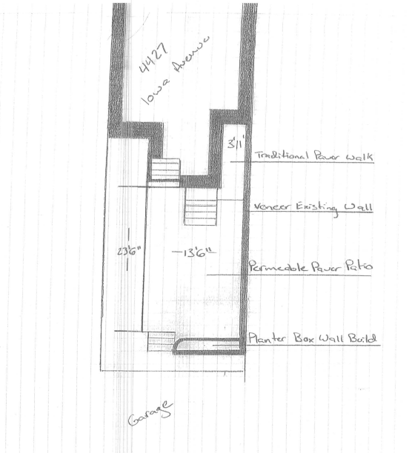

- Sketch of dimensions, design, and cross section

- Description of type of paver and sub-base material, and depth of each layer

- Name of contractor, contact information, license number

- Estimated cost or invoice from contractor

**Important Note: if the impervious surface to be replaced falls into public space, then the property owner must secure the necessary public space permits. For more information visit: https://tops.ddot.dc.gov/DDOTPERMITSYSTEM/DDOTPERMITONLINE/Landing.aspx

Site Design Guidelines for Impervious Surface Removal
The area where impervious surfaces are removed must be prepped for green space/garden installation. The exposed soil must be tilled or mixed so that it is no longer compacted, and either sod or plant material must be planted. We encourage the use of native plants; visit http://nativeplantcenter.net/ for more information on native plants to the Chesapeake Bay.

Please email a document that includes the following Site Design Specifications for pre-construction approval.
Example of Site Design Sketch

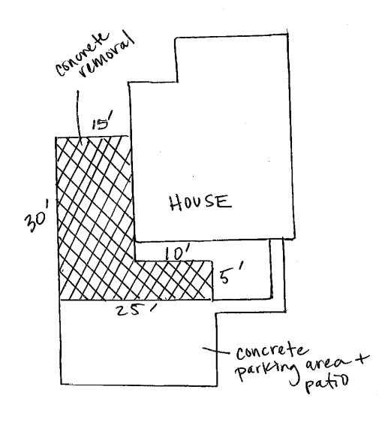

The Site Design Specifications:

- Area of impervious surface to be removed

- Remaining paved area

- Sketch of dimensions and design

- Materials/Plant List

- Name of contractor (optional)

- Estimated cost

